Informacije za ŠTAND:

Kontakt informacije:

Naziv lokalne zajednice: Grad Vinkovci
Ime i prezime osobe/osoba koja će se nalaziti na štandu (virtualnom) u toku sajma:
Hrvoje Niče
Kontakt e-mail: hrvoje.nice@vinkovci.hr
Kontakt Telefon: +385 (0)32 493308
Adresa, grad, država: Bana Jelačića 1, 32100 Vinkovci, RH
Link za zoom ili neki drugi komunikator preko kojeg želite održavati B2B sastanke:
Web adresa: www.grad-vinkovci.hr
Linkovi za društvene mreže:

O LOKALNOJ ZAJEDNICI:

Navedite sve informacije o Vašoj lokalnoj zajednici za koje smatrate da su bitne u predstavljanju (poželjno i na engleskom jeziku zbog ino-partnera), kako biste publici i investitorima približili vašu sredinu, sve ideje za buduće projekte i investicije, poslovne zone i dr. za privlačenje kapitala. Navedite i sve najbitnije kompanije iz Vaše sredine iz raznih djelatnosti kako bi mogli također komunicirati sa potencijalnim investitorima.
Dostavite i gotove PROJEKTE koje imate za ponuditi investitorima, kako bi ih mogli postaviti na platformu gdje će ih vidjeti investitori.

Pored ovih informacija u word-u odvojeno trebate dostaviti:

- Video promo o Vašoj lokalnoj zajednici ili link gdje je prikazan
https://youtu.be/uOCjtrZRa0o

- Brošure, slike, sve što smatrate da je zanimljivo iz Vaše lokalne zajednice koje će da stoje u rubrici O Lokalnoj zajednici.

- LOGO lokalne zajednice koji želite da se nalazi na štandu i logo kompanija iz Vaše sredine

Ovaj sajam će biti aktivan tokom cijele godine.



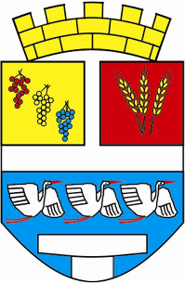

ADVANTAGES OF INVESTMENT IN
VINKOVCI

ABOUT THA LOCAL COMMUNITY

GENERAL INFORMATION

Town Vinkovci

County: Vukovar-Srijem
Area: 102,805 ha (60,623 ha of fields)
Population (2011): 35,312
Climate: mild continental
Unemployment rate (2021): 4,6 % VSC average in relationship Croatia
Average gross salary (2018): 589,00 EUR (64,5% of Croatian average)
GDP per capita VSŽ (2018): 6,589 EUR (58,5% of Croatian average)

Picture 1. Position of town Vinkovci in EU, Croatia and Vukovar-Srijem County


Source: Town Vinkovci
Vinkovci has a favorable geo traffic position in the vicinity of Pan-European Corridor X and VC, road and rail corridors that connect Western Europe with Middle East, as well as Central Europe with The Adriatic Sea.
There is a 30km distance to Osijek airport and 20km distance to Vukovar port and Pan-European corridor VII which represent the most important inland Danube waterway from Germany to The Black Sea.

Picture 2. Position of Vinkovci on main traffic routes

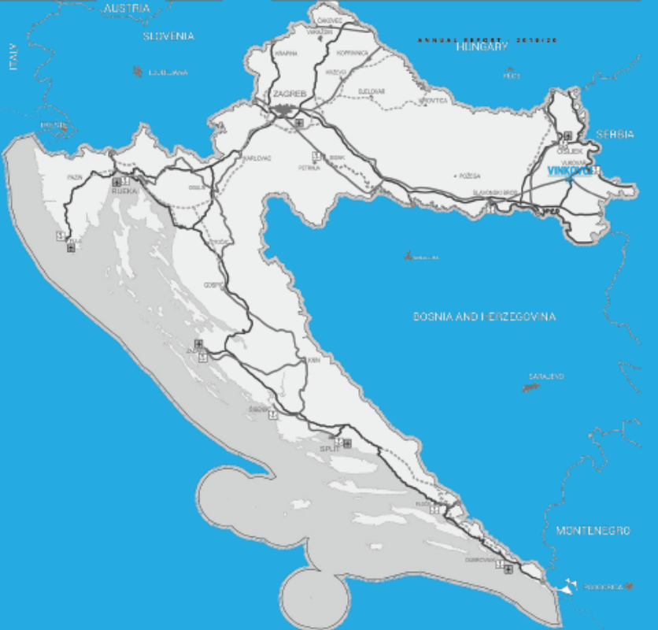
Source: Town Vinkovci

The area of Vinkovci is rich with cultural, archeological and historical attractions. Due to its favorable geographical position, many different cultures influenced the area and left material traces, such as archeological sites which prove as evidence of continuously inhabited area for 8,300 years, therefore Vinkovci is the oldest settlement in Europe.

Town tourism is based on the use of natural resources (watercourses, forests, protected areas, agricultural lowland area), rich archeological sites and cultural heritage. There are thousands of archeological sites in the town area. Also, the town is proud of the fact that it is a birthplace of two Roman emperors, Valentinian and Valens. As a cultural offer of the town¸ there are many events that take place in authentic locations: Carnival horse riding, Winter Šokci Talks, Vinkovci carnival, DORF (festival of documentary film), Puppeteer spring in Vinkovci, Health fair, Seminar on creating traditional hairstyles, Actor festival and Roman days.

BASIC ECONOMIC DATA

Town Vinkovci has a significant part in County indicators in the way that there are over 32,08% entrepreneurs who employ over 41,83% of employed persons, and realize 26,17% of total County profit.

In the summary, you will notice the relevant sizes of all existing business entities for 2019. Amounts in Kn:

entrepreneurs 693 | MIKRO | SMALL | MEDIUM | LARGE
Share capital | 68.849.840,00 | 163.834.516,00 | 513.752.757,00 | 293.185.640,00
Revenues | 1.295.998.816,00 | 1.371.313.254,00 | 1.223.874.022,00 | 1.077.296.261,00
Employees | 2.493 | 1.848 | 1.913 | 2.117
Assets | 1.328.587.821,00 | 1.564.959.175,00 | 793.189.087,00 | 978.067.337,00
Money | 76.569.244,00 | 74.493.665,00 | 80.949.692,00 | 22.247.710,00
Net profit | -14.275.022,00 | 46.717.662,00 | 208.860.256,00 | 35.638.704,00
Investments | 69.468.204,00 | 36.446.247,00 | 31.563.286,00 | 66.482.164,00
Export | 262.560.326,00 | 177.416.784,00 | 120.732.119,00 | 246.367.752,00

Table 1: Summary of relevant comparative quantities for 2019.

The most important economic sectors in Vinkovci are wood processing and food sectors.
Vinkovci is traditionally crafts town with the total of 547 registered craftspeople.
Total number of entrepreneurs 693.

THE CITY OF VINKOVCI is the center of education in Vukovar-Srijem County.
Following those:

EDUCATIONAL INSTITUTIONS 7 primary schools, 8 secondary and 2 faculty educational institutions

Table 2. High schools by type of program and students 2019/2020 in Vinkovci
Schools | Number of students
Schools | 2019./2020. | %
Gymnasiums | 875 | 24,2
Technical and related schools | 2005 | 55,5
Art high schools | 37 | 1,04
Industrial and craft schools | 666 | 18,4
Special high schools | 28 | 0,74
TOTAL | 3611
Source DSZ

FACULTY INSTITUTIONS
Professional study Wood Technology, Faculty of Forestry and Wood Technology, University of Zagreb.
On October 5, 2020, the Vinkovci Music School hosted a formal reception for the first generation of students at the undergraduate professional study Wood Technology at the Faculty of Forestry and Wood Technology, University of Zagreb, which will take place from the academic year 2020/2021. performed in Vinkovci. The study lasts 3 years or 6 semesters, and it earns 180 ECTS credits. Students enroll in 27 compulsory courses, final thesis, and from the offer of electives, two elective courses in the 5th and 6th semester. The academic title upon completion of the study will be: Professional bachelor (baccalaureus / baccalaurea) engineer of wood technology.
Undergraduate full-time professional study of computer science Vinkovci.
In the next academic year, 2021/2022, the Faculty of Electrical Engineering, Computing and Information Technologies Osijek (FERIT) will begin training students, through a dislocated undergraduate full-time professional study of computer science in Vinkovci. The professional study will last 6 semesters, and students will gain 180 ECTS credits upon completion. The acquired title will be a professional bachelor's degree in computer science.

SUPPORT OF THE CITY OF VINKOVAC FOR ENTREPRENEURS
Creating an environment for accelerated economic development is one of the most important priorities of the City of Vinkovci. Therefore, numerous projects have been launched aimed at building business infrastructure (incubators, business zones, logistics center, etc.).
In cooperation with the city's supporting entrepreneurial institutions: the Vinkovci City Development and Investment Agency, the Vinkovci Technology Park with the new Vinkovci Business Incubator, and ultimately through the work of the City Administration, entrepreneurs are provided with assistance and support in business development and investment, job creation and increase. competitiveness of entrepreneurs.
The City of Vinkovci annually allocates about 2 mil. HRK grants to entrepreneurs operating in the Vinkovci area. The purpose of the program is to create a more favorable entrepreneurial environment for the activities of entrepreneurs and attract investors with the aim of encouraging the overall economic and social development in the city of Vinkovci. The program to encourage entrepreneurship in the city of Vinkovci includes the following support measures:
MEASURE 1 - Investment in technology and human resources
MEASURE 2 - New entrepreneurs
MEASURE 3 - Subsidy for connection to municipal waterworks of existing entrepreneurs
MEASURE 4 - Interest subsidy on loans and credits for entrepreneurs
MEASURE 5 - Promotion of the economy
MEASURE 6 - Entrepreneurship incubator
MEASURE 7 - Assistance to entrepreneurs with difficulties in business due to the coronavirus virus of the Program to encourage agriculture in the city of Vinkovci for 2020 - 2021 includes the following support measures:
MEASURE 1 - Investments in the fruit sector, vegetables and floriculture
MEASURE 2 - Investment in the livestock and poultry sector
MEASURE 3 - Organic production in agriculture
MEASURE 4 - Beekeeping production
MEASURE 5 - Mushroom production
MEASURE 6 - Beginners In addition to grants by the decision of the City Council of Vinkovci entrepreneurs engaged in production and service activities is the compensation of the communal contribution from the maximum 50.00 kn / m³ to 1.00 kn / m³ in the entire city of Vinkovci.

AREAS SUITABLE FOR INVESTMENTS

- ENTREPRENEURIAL ZONE JOŠINE
It is situated in the south-east part of Vinkovci, its location is excellent due to the vicinity of important roads: Lipovac-Zagreb and Lipovac-Beograd highway.
- Zone size 75,165 m²
- Size of available land 54,268 m²
- Land use Production and service
- Land selling price based on production and
service investment plan, and the number
of new workplaces 2,00 to 10.67 EUR / m²
- Local rates for all businesses 0,13 EUR / m³
- Exemption from paying local rates to 97%
- Utility equipment: gas, electricity, water, drainage
- The level of activation is 74%
- Only one free parcel of land 1.594 m²
- By selling parcels, entrepreneurs are given supports through lower prices of building land in value of approximately 5,5 million kuna (estimated).

Picture 3. Entrepreneurial zone Jošine sketch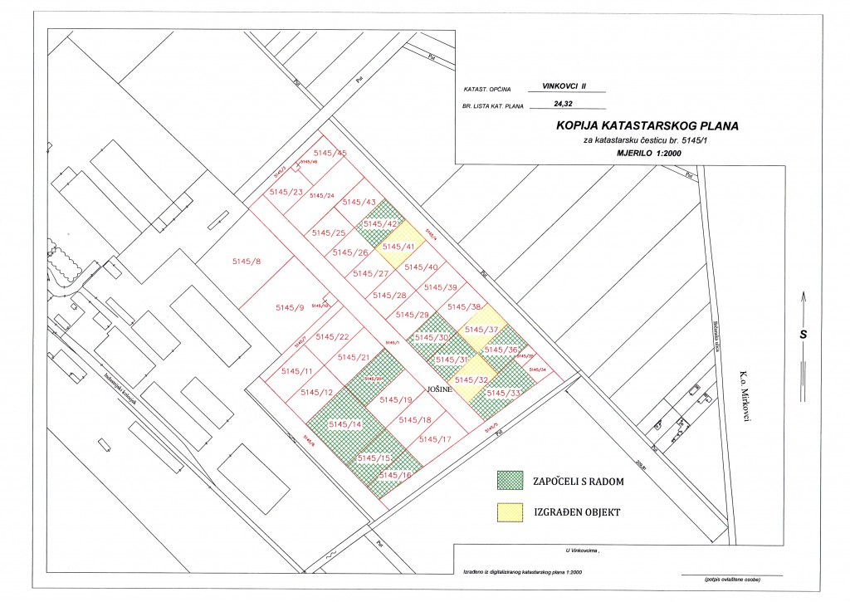
Source: Town Vinkovci

- INDUSTRIAL ZONE ZALUŽJE

Location - south-east part of the town by the state road Vinkovci – Županja, its location is excellent due to the vicinity of important roads: Lipovac-Zagreb and Lipovac-Beograd highway.

Zone size 38,42 ha
Entrepreneurs intended 29.32 ha
The level of activation 97,88 %
Planned extension zone 160 ha

By extending this zone, entrepreneurs´ supports would be provided through lower prices of building land in value of 1.733,333 EUR.

Picture 4. Entrepreneurial zone Zalužje
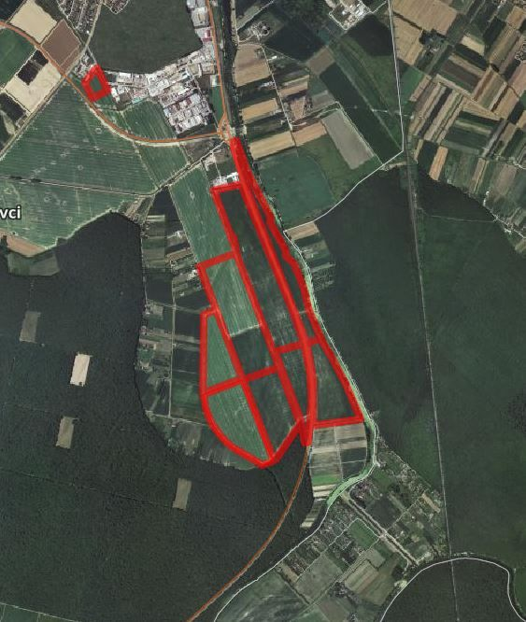
Source: Town Vinkovci

ENTREPRENEURIAL SUPPORTING INSTITUTIONS

- INVESTMENT AND DEVELOPMENT AGENCY OF THE CITY OF VINKOVCI – VIA Ltd.
ENTREPRENEUR INFORMATION CENTER is active within the agency and it was initiated by the support of Ministry of Economy, Entrepreneurship and Crafts. It provides services to entrepreneurs of Vinkovci area and other interested investors:

• information and counseling upon starting business,
• business planning, business plan design service and investment studies,
• information, counseling and help with preparation and implementation of planned investments and EU projects.

Despite helping entrepreneurs, The Agency tries to enhance entrepreneurial environment through numerous projects it develops and applies in partnership with the town Vinkovci and key local stakeholders. The Agency´s aim is to create conditions for entrepreneurial growth through next groups of activities:

- Developing entrepreneurial climate
- Developing entrepreneurial infrastructure
- Entrepreneurship promotion
- Support in entrepreneurial projects development
- Education for entrepreneurship

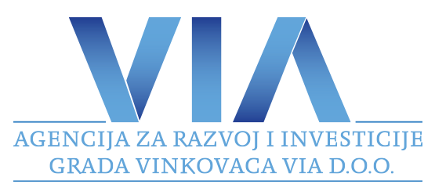

danijela.slipcevic@viavinkovci.hr
www.viavinkovci.hr

II TECHNOLOGY PARK VINKOVCI Ltd.

Technology Park Vinkovci doo is a company founded with the aim of affirming the entrepreneurial spirit in Vinkovci, but also the entire Vukovar-Srijem County.

Newly founded business entities in Technological park have preferential tariffs of rent during the time of business entity incubation for 5 years, free speed internet, the use of conference rooms, preliminary contract on the address when opening a company:
Business lease in Technological park Vinkovci

First year of lease 0% of the market lease rate 6,00 EUR/m²
Second year of lease 25% of the market lease rate 6,00 EUR/m²
Third year of lease 50% of the market lease rate 6,00 EUR/m²
Fourth year of lease 75% of the market lease rate 6,00 EUR/m²
Fifth year of lease 100% of the market lease rate 6,00 EUR/m²

Annual subvention per entrepreneur in the first year is approximately 2,200 EUR for the office rent of 30 m².

Overhead expenses
For five years of rent the price of overhead expenses is 2,00 EUR/m²

The development of new services:
Virtual office, mentorship, transfer of knowledge and technology, support to establishing quality systems, attaining attests and certificates, enhancing organizations and management, education, fair appearance, business rules on foreign markets etc.
picture 5. Technological park Vinkovci Ltd.
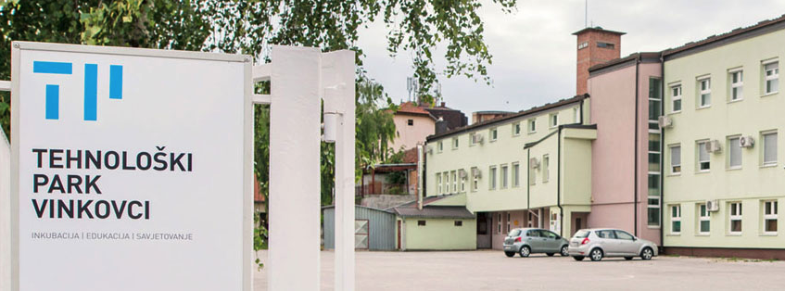Source: http://tp-vk.hr/

III BUSINESS INCUBATOR VINKOVCI (implemented 2020)
The aim of the project is to improve the business infrastructure and business of small and medium-sized enterprises with the aim of facilitating its growth and development and creating opportunities for job creation in the City of Vinkovci and Vukovar-Srijem County.

Location 5678 cadastral parcel Vinkovci II, total area 5,214 m²
Total gross area of the object: 2,147 m²

- 5 production areas 759 m²
- 14 business offices 1,388 m²
- administrative part of the building 97 m²
- conference room 100 m²
- multi-purpose room 100 m²

Surface of access roads and parking lots 3,178 m²
Green surface 1,122 m²

Existing object is completely reconstructed, and a new part of the object is built.

Picture 6. Business incubator Vinkovci www.inkubator-vinkovci.eu
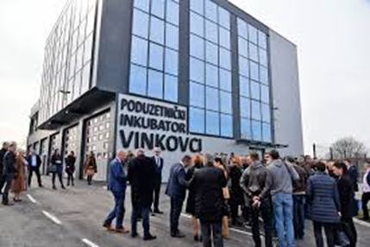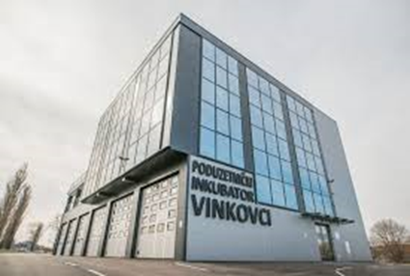

Source: Town Vinkovci

STRATEGIC PROJECTS OF THE TOWN VINKOVCI

Table 4. Selected development projects of the City of Vinkovci

NAZIV PROJEKTA  PROJECT NAME | KRATKI OPIS PROJEKTA  SHORT DESCRIPTION OF THE PROJECT | VRIJEDNOST PROJEKTA u EUR PROJECT VALUE in EUR
City Library and reading room Vinkovci  In the process | The project plans to build a 4,482 m2 city library and reading room building. | 5.500.000
Museum with interpretation center  In plan | The project plans to build a 7.900 m2 building, which will include a museum gallery, a souvenir shop and a planetarium, for the presentation of a rare valuable luxury silverware dating site dating from the end of the 4th century found in the center of Vinkovci. | 9.160.000
Reconstruction and presentation of the early Christian church of St. Elijah in Meraj  In plan | The project is planning to reconstruct the Gothic church in Meraj in the gallery-space area in order to strengthen the tourist infrastructure and offer Vinkovci as the oldest city in Europe. | 1.225.600
Development of broadband access in the Vinkovci area  In plan | The project contributes to the achievement of the national strategic goals set by the Strategy for Development of Broadband Access in the Republic of Croatia in the period 2012-2015 and the Digital Agenda for Europe in the period up to 2020, especially in the aspect of ensuring the availability of fast and ultra-fast broadband access. | 12.500.000
Construction of a market  In plan | The project is planning to build a new semi-open market for marketing and marketing of local agricultural products - a combination of rural and urban. | 2.400.000
Construction of overpasses via the Zagreb - Tovarnik railway line  In the process | The project planned the construction of overpasses via the Zagreb - Tovarnik railway line, which would connect the Borinci settlement with the better road infrastructure with the center of the town of Vinkovci. The project encourages intermodal traffic, as it would improve the linkage of road freight with railways, thereby disrupting part of the city's traffic. | 10.600.000
Source: Town Vinkovci

Selected projects in project realization

TLC - Transport Logistics Center

The project "Transport and Logistics Center of Vukovar-Srijem County" is, due to its importance and possible significant impact on economic development, job creation, investment attraction and general raising of living standards, defined as a strategic project of Vukovar-Srijem County.

The project idea is based on the use of the geostrategic position of Vukovar - Srijem County, which is a significant comparative advantage compared to neighboring counties and the region of Eastern Europe as a whole. The position of Vukovar - Srijem County is the basis for the intensive development of the logistics - transport component, given that significant European traffic routes (river, railway and road) intersect in the county.

For the geo-traffic position of the Transport and Logistics Center in Vinkovci, the most important railway traffic route is Corridor X: (Ljubljana, Dobova) - Savski Marof - Zagreb - Novska - Strizivojna / Vrpolje - Vinkovci - Tovarnik - (Sid, Belgrade). The location of the Transport and Logistics Center of Vukovar-Srijem County is at the former freight station of the city of Vinkovci, which is not in function.

Project-technical documentation is currently being prepared in order to proceed with the construction of the necessary infrastructure on the 500,000 m2 zone, which is planned for 2022 and 2023. The project plans to build a total of 1,400 meters of industrial tracks.
The Transport and Logistics Center will be a hub for the wider region in this part of Eastern Europe, in which private businesses will perform transport, logistics and distribution of goods (in national and international transit), on a commercial basis (distribution centers, wholesale, warehousing and transport, logistics and service centers, etc.).

Other economic activities of interest to TLC users (production, finishing, handling and storage of products) are also planned, in accordance with the needs of the user and its basic purpose. This project is in the function of attracting investors by highlighting the competitive advantages of the area, but also the opportunities for the construction of logistics, distribution and production facilities with a significant reduction in the total initial costs of construction and start-up.

The project of the Transport and Logistics Center of Vukovar-Srijem County has a regional investment in terms of its size, and after the completion of the entire investment, it will also have national significance.
The project is intended for the development of transport and logistics activities and the return of the importance of the City of Vinkovci and Vukovar - Srijem County as an important transport hub.

Project - Hungarian School

Educational and Development Center Vinkovci

The duration of the project is from May 15, 2020 to May 15, 2023, and after the preparation of project-technical documentation will apply for funds for the reconstruction of the building whose purpose is to accommodate educational and sports-recreational institutions and associations to contribute to improving the educational structure the city of Vinkovci and Vukovar-Srijem County, and the development of an economy based on knowledge and innovation.

First of all, the building will have the space of the Josip Runjanin Music School, the College of Informatics with an innovation and development center, which is in the process of being established in cooperation with the College of Information Technology Zagreb, and the Study of Wood Technology.

Investment areas of the City of Vinkovci according to the resources of the area.

FORESTRY - Slavonia is rich in forests and the famous Slavonian oak, which enables the production, processing of wood and production of wood products.

FOREST ADMINISTRATION VINKOVCI BRANCH

The Vinkovci branch consists of 12 forestry that take care of and maintain them.

Economic potentials:

Significant companies operating in the area of ​​Vinkovci.

SPAČVA D.D.

Spačva is today a successful, stable and promising company. The leading wood industry in Croatia in terms of size, organization, management approach and business transparency. It currently employs 850 workers, making it one of the largest employers in the wood industry, Vukovar-Srijem County and Vinkovci. It produces exclusively final products, mostly in oak, which it primarily exports. The products can be purchased in 30 countries around the world, and the most important markets are France, Italy and Germany. The results they have achieved so far are a good basis for achieving the European level of competitiveness.

PRODUCTION OF TILES AND BRICKS

Nexe group / DILJ d.o.o.

DILJ d.o.o. Vinkovci was founded in 1922.
It is engaged in the production of tiles, and in the Slavonia IGM Factory in Našice the production of bricks.
It is a company of tradition and continuity, customer-oriented, which continuously strives to meet customer expectations with regard to the quality and price of its products.

Construction company

SOKOL d.o.o.

It is an established contractor of construction and assembly works of civil engineering and building construction with many years of experience in the construction and maintenance of energy and telecommunications lines and networks, pipelines and installations and buildings for various purposes.

CESTORAD D.D.

After the development and experience gained over 20 years in the field of civil engineering, and especially road construction, since 1990 the company operates under the name Cestorad d.d. as a joint stock company that is 100% owned by employees.
Today it is a modernly organized company with about 150 employees, mostly highly educated and highly qualified staff. CESTORAD D.D. has the most modern mechanization for road construction, whether it is preparatory earthworks or final asphalting works, and a completely new microprocessor-controlled asphalt base of large capacity.
Operating on the market of eastern Croatia, especially the Vukovar-Srijem County, and neighboring Bosnia and Herzegovina, the company CESTORAD D.D. has gained a great reputation, but also the obligation to continue to prove itself as a leading company in civil engineering in the area.

WATMONT D.O.O.

The company is 100% privately owned.
Through hard work, commitment and investment, it has developed into a respectable business entity in the area of ​​the city of Vinkovci, which always employs over 100 employees of various professions related to the performance of construction and craft works.
The trend of growth and constant employment of new workers has been recorded for the last 10 years.
It is geographically covered regionally, and bases its business on the domestic market. One of the essential areas that helps create the long-term competitive advantage of this serious company is human resource management. The ability to respond to competitive market conditions is the result of the fact that there are enough people in the company structure with the appropriate knowledge, skills and motivation, therefore, workers play a significant role in the conception and application and development of business goals that affect the financial results and overall reputation and efficiency of the company. The company Watmont d.o.o. has a large number of special machines and equipment that enables fast and quality execution of projects in all areas of construction.
Construction and craft work performed by Watmont d.o.o. include:
• Construction works • Electrical installation works • Energy renovation • Facade works • Painting works • Plasterboard works • Carpentry works • Locksmith works • Carpentry works. In addition to performing construction and craft works,
Watmont d.o.o. also has its own PVC production.

RASPON d.o.o.

for construction, trade and services Vinkovci, is a contractor of civil engineering and building construction, with many years of experience in the construction of residential, public and commercial buildings.
The Ministry of Environmental Protection, Physical Planning and Construction issued on 31.03.2009. year consent for the execution of works of group F construction.
The company Raspon d.o.o. currently employs 50 employees of various professions with certain qualifications, medical certificates and certificates of competency to work in a safe manner in the field of occupational safety.
The structure of employees, their equipment and all the necessary supporting documentation ensures the quality construction of these buildings. The company Raspon d.o.o. owns a vehicle fleet, the necessary mechanization and tools that have all the necessary attestation documentation and testing certificates in the field of occupational safety.
In addition to the construction business, we sell and service all types of tires, which includes a well-equipped workshop for all types of vehicles.

AKSION d.o.o.

In our many years of practice, we have performed work on a number of family houses and business facilities. Since 1996, we have been engaged in the renovation of family houses in our counties: • Sisak - Moslavina • Vukovar - Srijem • Šibenik - Knin

BODAT d.o.o.

The company Bodat doo was founded in 1990. The original activity was the sale of construction materials and firewood. Over time, we have expanded our business and today the company is engaged in the sale and distribution of construction materials, and the execution of all types of construction work, as well as the transport of bulk cargo and construction materials. The building material warehouse offers complete construction material for the construction of all types of buildings. In addition to the warehouse in Vinkovci, we also have a warehouse for construction materials in Županja, JJ Strossmayera bb on over 11,000 m2.

AMM d.o.o.

AMM was founded in 1993 for civil engineering activities and has been privately owned ever since. Our vision is to be an unavoidable partner in the field of activity, to offer top service to our clients at competitive prices and from the first day we are guided by that thought and after 20 years of work where we completed all projects and handed them over to the investor vision. There were really a lot of projects, over 80.
It all started with works on the telecommunications network of the Croatian telecom operator in the area of ​​Eastern Slavonia, where the majority of our projects were carried out.
In those first two years, we completed 100 km of telecommunications network.
Later, the investor's activity was transferred to gas, and in the following years we worked on the construction of gas networks, and subsequently water and sewage. In the past 20 years, we have built a total of 500 km of infrastructure networks in all materials, dimensions and purposes with accompanying facilities with a total value of our services over 25 million euros.

SUHOMONT d.o.o.

In our offer we offer services of engineering solutions and execution of works in the field of electrical engineering, mechanical engineering and construction.

Contact:

Town Vinkovci
Bana Jelačića 1, 32100 Vinkovci
Contact person: Hrvoje Niče
+385 32 337 200
hrvoje.nice@vinkovci.hr
www.vinkovci.hr

INVESTMENT AND DEVELOPMENT AGENCY
OF THE CITY OF VINKOVCI – VIA Ltd.
Glagoljaška 4, 32100 Vinkovci
Contact person: Danijela Slipčević
+385 32 340 030
danijela.slipcevic@viavinkovci.hr
www.viavinkovci.hr

OPĆE INFORMACIJE

Grad Vinkovci

Županija: Vukovarsko-srijemska
Površina: 102.805 ha (od toga 60.623 ha oranica)
Stanovništvo (2011): 35.312
Klima: blaga kontinentalna
Stopa nezaposlenosti (2021): 4,6 % VSŽ u odnosu na RH
Prosječna neto plaća (2018): 589 EUR (64,5% prosjeka RH)
GDP per capita VSŽ (2018): 6,589 EUR (58,5% prosjeka RH)

Slika 1. Položaj Grada Vinkovaca u EU, RH i VSŽ

Izvor: Grad Vinkovci

Povoljan geoprometni položaj Vinkovaca karakterizira neposredna blizina Paneuropskih koridora X i VC, cestovnih i željezničkih koridora koji spajaju Zapadnu Europu s Bliskim istokom, te Srednju Europu s Jadranskim morem.
Od zračne luke Osijek Vinkovci su udaljeni 30 km, a od Luke Vukovar i Paneuropskog koridora VII koji predstavlja najvažniji unutarnji plovni put Dunavom od Njemačke do Crnog mora, Vinkovci su udaljeni 20 km.

Slika 2. Smještaj Vinkovaca na glavnim prometnim koridorima

Izvor: Grad Vinkovci

Područje Grada Vinkovaca je bogato kulturnim, arheološkim i povijesnim atrakcijama te mu je njegov povoljan zemljopisni položaj omogućio utjecaj različitih kultura koje su ostavile materijalne tragove o čemu svjedoče arheološka nalazišta, putem kojih možemo pratiti kontinuirano naseljavanje ovoga prostora kroz 8.300 godina, čime su Vinkovci najstarije naselje u Europi.

Turizam Grada razvija se na temelju korištenja prirodnih resursa (vodotoci, šume, zaštićena područja, poljodjelski ravničarski prostor), bogatih arheoloških nalazišta i kulturne baštine. Na području grada pronađeno je i na tisuće arheoloških nalaza, a Vinkovci se mogu pohvaliti i kako su na području grada rođena dva rimska cara, Valentinijan i Valens. Za kulturnu ponudu Grada Vinkovaca od velikog su značaja manifestacije koje se održavaju na autentičnim lokacijama: Pokladno jahanje, Zimski šokački divani, Vinkovački karneval, DORF, Lutkarsko proljeće u Vinkovcima, Sajam zdravlja, Seminar o izradi tradicijskih frizura, Festival glumca i Rimski dani.

OSNOVNI EKONOMSKI PODACI

Grad Vinkovci imaju značajan udjel u pokazateljima županije i to tako što se u gradu nalazi preko 32,08 % poduzetnika koji upošljavaju više od 41,83 % ukupno zaposlenih, te ostvaruju skoro 26,17 % ukupnog prihoda županije.

Vinkovci su tradicionalno obrtnički grad sa registriranih ukupno 547 obrtnika.
Ukupan broj poduzetnika 693.

U sažetom prikazu uočit ćete relevantne veličine svih postojećih poslovnih subjekata za 2019. godinu. Iznosi u Kn:

Ukupan broj  Poduzetnika 693 | MIKRO | MALI | SREDNJI | VELIKI
Temeljni kapital | 68.849.840,00 | 163.834.516,00 | 513.752.757,00 | 293.185.640,00
Prihodi | 1.295.998.816,00 | 1.371.313.254,00 | 1.223.874.022,00 | 1.077.296.261,00
Zaposlenih | 2.493 | 1.848 | 1.913 | 2.117
Imovina | 1.328.587.821,00 | 793. 189.087,00 | 1.564.959.175,00 | 978.067.337,00
Novac | 76.569.244,00 | 74.493.665,00 | 80.949.692,00 | 22.247.710,00
Neto dobit | -14.275.022,00 | 46.717.662,00 | 31.563.286,00 | 35.638.704,00
Investicije | 69.468.204,00 | 36.446.247,00 | 208.860.256,00 | 66.482.164,00
Izvoz | 262.560.326,00 | 177.416.784,00 | 120.732.119,00 | 246.367.752,00

Tablica 1: Sažeti prikaz relevantnih usporednih veličina za 2019. godinu.

GRAD VINKOVCI

su središte obrazovanja Vukovarsko - srijemske županije.
Slijedom navedenog:
OBRAZOVNE USTANOVE

7 osnovnih škola, 8 srednjih i 2 fakultetske obrazovne institucije

Tablica 2. Srednje škole prema vrsti programa i učenici 2019./2020. u Vinkovcima
Škole | Broj učenika
Škole | 2019./2020. | %
Gimnazije | 875 | 24,2
Tehničke i srodne škole | 2005 | 55,5
Srednje umjetničke škole | 37 | 1,04
Industrijske i obrtničke škole | 666 | 18,4
Specijalne srednje škole | 28 | 0,74
UKUPNO | 3611
Izvor: DZS (Srednje škole i učenički domovi)

FAKULTETSKE USTANOVE

Stručni studij Drvna tehnologija fakulteta šumarstva i drvne tehnologije Sveučilišta u Zagrebu

U prostoru Glazbene škole Vinkovci 5. listopada 2020. godine organiziran je svečani prijem prve generacije studenata na preddiplomskom stručnom studiju Drvna tehnologija Fakulteta šumarstva i drvne tehnologije Sveučilišta u Zagrebu, koji će se od akademske godine 2020./2021. izvoditi u Vinkovcima.

Studij traje 3 godine odnosno 6 semestara, a njime se stječe 180 ECTS bodova. Studenti upisuju 27 obaveznih predmeta, završni rad, a iz ponude izbornih po dva izborna predmeta u 5. i 6. semestru. Akademski naziv po završetku studija će biti: Stručni prvostupnik/prvostupnica (baccalaureus/baccalaurea) inženjer/inženjerka drvne tehnologije.

Preddiplomski redoviti stručnog studija računarstva Vinkovci.

Sljedeće akademske godine, 2021./2022., Fakultet elektrotehnike, računarstva i informacijskih tehnologija Osijek (FERIT) započet će s izobrazbom studenata, kroz dislocirani preddiplomski redoviti stručni studij računarstva u Vinkovcima. Stručni studij trajat će 6 semestara, a studenti će završetkom steći 180 ECTS bodova. Stečeno zvanje bit će stručni/a prvostupnik/prvostupnica inženjer/inženjerka računarstva

POTPORE GRADA VINKOVACA ZA PODUZETNIKE

Stvaranje okruženja za ubrzani razvoj gospodarstva jedan je od najvažnijih prioriteta Grada Vinkovca. Stoga su pokrenuti brojeni projekti usmjereni na izgradnju poslovne infrastrukture (inkubatora, poslovnih zona, logističkog centra i dr.).
U suradnji s gradskim potpornim poduzetničkim institucijama: Agencijom za razvoj i investicije grada Vinkovaca, Tehnološkim parkom Vinkovci s novim Poduzetničkim inkubatorom Vinkovci, a u konačnici kroz rad Gradske uprave, poduzetnicima se pruža pomoć i potpora u razvoju poslovanja i investiranja, otvaranju novih radnih mjesta I povećanju konkurentnosti poduzetnika.
Grad Vinkovci kroz provedbu Programa poticanja poduzetništva na području grada Vinkovaca i Programa poticanja poljoprivrede na području grada Vinkovaca godišnje dodijeli i oko 2 mil. HRK bespovratnih sredstava poduzetnicima koji djeluju na području Vinkovaca.
Svrha programa je stvaranje povoljnijeg poduzetničkog okruženja za djelovanje poduzetnika i privlačenje investitora s ciljem poticanja ukupnog gospodarskog i društvenog razvoja na području grada Vinkovaca.
Program poticanja poduzetništva na području grada Vinkovaca obuhvaća sljedeće mjere potpore:
MJERA 1 - Ulaganje u tehnologiju i ljudske potencijale
MJERA 2 - Novi poduzetnici
MJERA 3 - Subvencija priključka na komunalno vodne građevine postojećih poduzetnika
MJERA 4 - Subvencija kamata kredita i zajmova za poduzetnike
MJERA 5 - Promocija gospodarstva
MJERA 6 - Poduzetnički inkubator
MJERA 7 - Pomoć poduzetnicima s teškoćama u poslovanju zbog korona virusa
Programa poticanja poljoprivrede na području grada Vinkovaca za 2020. - 2021. godinu obuhvaća sljedeće mjere potpore:
MJERA 1 – Ulaganja u sektore voćarstva, povrtlarstva i cvjećarstva
MJERA 2 – Ulaganje u sektor stočarstva i peradarstva
MJERA 3 – Ekološka proizvodnja u poljoprivredi
MJERA 4 – Pčelarska proizvodnja
MJERA 5 – Gljivarska proizvodnja
MJERA 6 – Početnici
Osim bespovratnih potpora odlukom Gradskog vijeća Grada Vinkovaca poduzetnicima koji se bave proizvodnim i uslužnim djelatnostima smanjena je naknada komunalnog doprinosa sa maksimalnih 50,00 kn / m³ na 1,00 kn / m³ na području cijelog grada Vinkovaca.

PODRUČJA POGODNA ZA ULAGANJE

- PODUZETNIČKA ZONA JOŠINE
Nalazi se u jugoistočnome dijelu grada Vinkovaca, smještena je na odličnoj prometnoj lokaciji uz vrlo važne prometnice: autocestu Lipovac - Zagreb te Lipovac – Beograd.
- Veličina zone 75.165 m²
- Veličina dostupnog zemljišta 54.268 m²
- Namjena zemljišta Proizvodno-uslužna
- Prodajna cijena zemljišta
ovisno o planu ulaganja u proizvodnju
ili usluge, te broju otvorenih novih radnih mjesta 2,00 do 10.67 EUR / m²
- Komunalni doprinos za sve djelatnosti 0,13 EUR / m³
- Oslobađanje plaćanja komunalnog doprinosa do 97%
- Komunalna opremljenost: plin, struja, voda, odvodnja
- Stupanj aktivacije iznosi 74%
- Slobodna samo jedna parcela površine 1.594 m²
- Prodajom parcela dane su potpore poduzetnicima kroz povoljnije cijene građevinskog zemljišta u vrijednosti cca 5,5 miliona kuna (procjena).

Slika 3. Skica Poduzetničke zone Jošine Izvor: Grad Vinkovci

II. INDUSTRIJSKA ZONA ZALUŽJE

Lokacija - jugoistočni dio grada uz državnu cestu Vinkovci – Županja, smještena je na odličnoj prometnoj lokaciji uz vrlo važne prometnice: autocestu Lipovac-Zagreb te Lipovac – Beograd.

Ukupna površina zone 38,42 ha
Namijenjeno poduzetnicima 29.32 ha
Stupanj aktivacije 97,88 %
Planirano proširenje zone 160 ha

Proširenjem zone osigurale bi se potpore poduzetnicima kroz povoljnije cijene građevinskog zemljišta.

Slika 4. Poduzetnička zona Zalužje prikaz plana proširenja
Izvor: Grad Vinkovci

PODUZETNIČKE POTPORNE INSTITUCIJE

- AGENCIJA ZA RAZVOJ I INVESTICIJE GRADA VINKOVACA – VIA d.o.o.

U okviru Agencije djeluje INFO CENTAR ZA PODUZETNIKE koji je pokrenut je uz podršku Ministarstva gospodarstva, poduzetništva i obrta, te poduzetnicima s područja grada Vinkovaca i drugim zainteresiranima ulagačima pruža usluge:

• informiranje i savjetovanje prilikom pokretanja tvrtke,
• poslovno planiranje i usluge izrade poslovnog plana i investicijskih studija,
• informiranje, savjetovanje i pomoć u pripremi i provedbi planiranih ulaganja i EU
projekata.
Osim direktne pomoći poduzetnicima, Agencija nastoji poboljšati poduzetničko okruženje kroz brojne projekte koje razvija i prijavljuje u partnerstvu s Gradom Vinkovcima i ključnim lokalnim dionicima. Agencija djeluje u cilju stvaranja uvjeta za razvoj poduzetništva i to kroz slijedeće grupe aktivnosti:

- Razvoj poduzetničke klime
- Razvoj poduzetničke infrastrukture
- Promocija poduzetništva
- Potpora razvoju poduzetničkih projekata
- Obrazovanje za poduzetništvo

danijela.slipcevic@viavinkovci.hr
www.viavinkovci.hr

III. TEHNOLOŠKI PARK VINKOVCI d.o.o.

Tehnološki park Vinkovci d.o.o. je trgovačko društvo koje je osnovano s ciljem afirmacije poduzetničkog duha u Vinkovcima, ali i cijeloj Vukovarsko – srijemskoj županiji.
Novoosnovani poslovni subjekti u Tehnološkom parku imaju povlaštene cijena najma za vrijeme inkubacije poslovnog subjekta u trajanju od 5 godina, besplatni brzi internet, korištenje konferencijske dvorane, predugovor o adresi prilikom otvaranja poduzeća:

Najam poslovnog prostora u Tehnološkom parku Vinkovci

Prva godina najma 0% od tržišne cijene najma 6,00 EUR/m²
Druga godina najma 25% od tržišne cijene najma 6,00 EUR/m²
Treća godina najma 50% od tržišne cijene najma 6,00 EUR/m²
Četvrta godina najma 75% od tržišne cijene najma 6,00 EUR/m²
Peta godina najma 100% od tržišne cijene najma 6,00 EUR/m²

Godišnja subvencija po poduzetniku u prvoj godini cca 2.200 EUR za najam ureda površine 30 m².

Režijski troškovi
za svih pet godina najma cijena režijskih troškova iznosi 2,00 EUR/m²

Razvoj novih usluga:
virtualni ured, mentorstvo, prijenos znanja, transfer tehnologija, potpore uspostavi sustava kvalitete, dobivanja atesta i certifikata unapređenje organizacije i upravljanja, edukacije, nastupi na sajmovima, pravila poslovanja na stranim tržištima itd.

Slika 5. Tehnološki park Vinkovci d.o.o. www.tp-vk.hr
Izvor: http://tp-vk.hr/

IV. PODUZETNIČKI INKUBATOR VINKOVCI
(provedeno 2020)

Cilj projekta je poboljšati poslovne infrastrukture i poslovanje malim i srednjim poduzetnicima s ciljem njegovog olakšanog rasta i razvoja te stvaranja mogućnosti za otvaranje novih radnih mjesta na području Grada Vinkovaca i Vukovarsko-srijemske županije.

Lokacija 5678 k.o. Vinkovci II, ukupne površine 5.214 m²
Ukupna bruto površina objekta: 2.147 m²

- 5 proizvodnih prostora 759 m²
- 14 uredskih poslovnih prostora 1.388 m²
- upravni dio zgrade 97 m²
- konferencijska dvorana 100 m²
- višenamjenska dvorana 100 m²

Površina pristupnih cesta i parkirališta 3.178 m²
Zelene površine 1.122 m²

Poduzetnički inkubator predviđen za smještaj novoosnovanih malih poduzeća koja tek počinju poslovati ili su u fazi razvoja te postojećih tvrtki kojima je potreban prostor i stručna pomoć kroz savjetodavne, konzultantske te administrativne usluge i edukacije. Uz suvremeno opremljenu infrastrukturu poduzetnicima su na raspolaganju i brojne usluge kreirane tako da početnicima koji imaju dobru ideju
olakšaju prve korake u poduzetničkim vodama.
Slika 6. Poduzetnički inkubator Vinkovci www.inkubator-vinkovci.eu
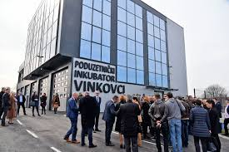

Izvor: Grad Vinkovci

STRATEŠKI PROJEKTI GRADA VINKOVACA

Tablica 4. Izdvojeni razvojni projekti Grada Vinkovaca.

NAZIV PROJEKTA  PROJECT NAME | KRATKI OPIS PROJEKTA  SHORT DESCRIPTION OF THE PROJECT | VRIJEDNOST PROJEKTA u EUR PROJECT VALUE in EUR
Gradska knjižnica i čitaonica Vinkovci  U realizaciji | Projekt planira izgradnju objekta 4.482 m2 gradske knjižnice i čitaonice. | 5.500.000
Muzej s interpretacijskim centrom  U planu | Projekt planira izgradnju objekta 7.900 m2 koji će sadržavati muzejsko - galerijski prostor, suvenirnicu i planetariji, a u cilju je prezentacije rijetko vrijednog nalazišta luksuznog srebrnog posuđa koje datira s kraja 4. stoljeća pronađenog u centru Vinkovaca. | 9.160.000
Rekonstrukcija i prikaz ranokršćanske crkve sv. Ilije na Meraji  U planu | Projektom se planira rekonstrukcija gotičke crkve na Meraji u galerijsko-izložbeni prostor u cilju jačanja turističke infrastrukture i ponude Vinkovaca kao najstarijeg grada u Europi. | 1.225.600
Razvoj širokopojasnog pristupa na području Vinkovci  U planu | Projekt pridonosi ostvarenju nacionalnih strateških ciljeva zadanih Strategijom razvoja širokopojasnog pristupa u RH u razdoblju 2012.-2015., te Digitalnom agendom za Europu u razdoblju do 2020., posebno u dijelu osiguranja dostupnosti brzog i ultra-brzog širokopojasnog pristupa. | 12.500.000
Izgradnja tržnice  U planu | Projektom bi se izgradio objekt nove tržnica poluotvorenog tipa u cilju promidžbe i trženja lokalnih poljoprivrednih proizvoda - spoj ruralnog i urbanog. | 2.400.000
Nadvožnjak preko željezničke pruge Zagreb – Tovarnik  U realizaciji | Projektom planirana izgradnja nadvožnjaka preko željezničke pruge Zagreb – Tovarnik koji bi se naselje Borinci kvalitetnijom cestovnom infrastrukturnom povezalo s centrom grada Vinkovaca. Projektom potiče inter modalni promet jer bi se unaprijedila povezanost cestovnog teretnog prometa sa željezničkim, a time bi se rasteretio dio gradskog prometa. | 10.600.000
Izvor: VIA d.o.o.

Izdvojeni projekti u projektnoj realizaciji

TLC – Transportni logistički centar

Projekt "Transportno-logistički centar Vukovarsko-srijemske županije" je, zbog svoje važnosti i mogućeg značajnog utjecaja na gospodarski razvoj, otvaranje novih radnih mjesta, privlačenja ulaganja i općenito podizanje životnog standarda, određen kao strateški projekt Vukovarsko-srijemske županije.
Projektna ideja zasniva se na korištenju geostrateškog položaja Vukovarsko – srijemske županije, što je značajna komparativna prednost u odnosu na susjedne županije i regiju Istočne Europe u cjelini. Položaj Vukovarsko - srijemske županije je osnova za intenzivni razvoj logističko - transportne komponente, obzirom da se na području županije sijeku značajni europski prometni pravci (riječni, željeznički i cestovni). Za geoprometni položaj Transportno-logističkog centra u Vinkovcima najznačajniji je željeznički prometni pravac X koridor: (Ljubljana, Dobova) - Savski Marof - Zagreb - Novska - Strizivojina/ Vrpolje -Vinkovci - Tovarnik - (Šid, Beograd).
Lokacija Transportno-logističkog centra Vukovarsko-srijemske županije je na nekadašnjem teretnom kolodvoru grada Vinkovca koji nije u funkciji. Trenutno je u izradi projektno-tehnička dokumentacija kako bi se potom pristupilo izgradnji potrebne infrastrukture na 500.000 m² zone što se planira tijekom 2022. i 2023. godine. U okviru projekta planira se izgradnja ukupno 1400 metara industrijskih kolosijeka. Transportno-logističkog centra biti će hub za područje šire regije u ovom dijelu Istočne Europe, u kojem će privatni poslovni subjekti obavljati djelatnosti prijevoza, logistike i distribucije robe (u nacionalnom i međunarodnom tranzitu), na komercijalnoj osnovi (distributivni centri, veletrgovina, skladištenje i transport, logističko-servisni centri i dr.). Također se planiraju i ostale gospodarske djelatnosti od interesa za korisnike TLC a (proizvodnja, dorada, manipulacija i skladištenje proizvoda), u skladu s potrebama korisnika i njegovom osnovnom namjenom.
Ovaj projekt u funkciji je privlačenja investitora isticanjem konkurentskih prednosti područja, ali i mogućnosti za izgradnju logističkih, distribucijskih i proizvodnih objekata uz znatno smanjenje ukupnih početnih troškova izgradnje i pokretanja poslovanja.
Projekt Transportno-logističkog centra Vukovarsko-srijemske županije svojom veličinom ulaganja ima regionalni, a nakon dovršetka cjelokupne investicije, imat će i nacionalni značaj. Projekt je namijenjen razvoju transportno – logističke djelatnosti te vraćanju značaja Grada Vinkovca i Vukovarsko – srijemske županije kao važnog prometnog čvorišta.

IZRADA PROJEKTNO-TEHNIČKE DOKUMENTACIJE OBRAZOVNO-RAZVOJNOG CENTRA VINKOVCI

Trajanje projekta: 15. svibnja 2020. do 15. svibnja 2023.

Cilj projekta:
Projekt „Izrada projektno-tehničke dokumentacije Obrazovno-razvojnog centra Vinkovci“ razvija se u okviru napora Grada Vinkovaca usmjerenih na pripremu zaliha strateških projekata regionalnog razvoja. Cilj projekta je izrada projektno-tehničke dokumentacije za rekonstrukciju zgrade „Mađarske škole“ koja će biti namijenjena smještaju obrazovnih i razvojnih ustanova, a u svrhu doprinosa poboljšanju obrazovne strukture grada Vinkovaca i Vukovarsko – srijemske županije. Obnovljeni objekt biti će u potpunosti prilagođen potrebama razvoja suvremenih programa i sadržaja u obrazovanju.

Prije svega u zgradi će svoj prostor imati Glazbena škola Josipa Runjanina, Visoka škola za informatiku s inovacijsko-razvojnim centrom koja je u procesu osnivanja u suradnji s Visokom školom za informacijske tehnologije Zagreb, te Studij drvne tehnologije.

Gospodarski potencijali i mogućnosti razvitka Vukovarsko – Srijemske županije
i grada Vinkovaca

Gospodarske potencijale Županije predstavljaju prirodni resursi i to
poljoprivredne obradive površine, šume, nalazišta nafte i plina, pijeska i šljunka,
vodni tokovi i zemljopisni položaj, kao i proizvodni i uslužni kapaciteti, visokovrijedni
ljudski potencijal, te bogata kulturno-povijesna baština.

Tlo, blaga kontinentalna klima i povoljan godišnji raspored oborina ovog
podneblja omogućava kvalitetnu poljoprivrednu proizvodnju. Ratarske površine su
meliorirane i komasirane i omogućuju strojnu obradu i visoke prinose. Glavni
proizvodi su: pšenica, kukuruz, suncokret, soja, uljana i šećerna repa i povrće. U
stočarskoj proizvodnji najzastupljenije je svinjogojstvo i govedarstvo.
Poljoprivredne površine zauzimaju gotovo 150.000 ha ili 61% površine
Županije od kojih se 93% odnosi na oranice, 2,9% na pašnjake, 0,6% na livade,
1,4% na vinograde te 1,7% na voćnjake.

Ukupne šumske površine s nadaleko poznatim Spačvanskim bazenom
zauzimaju 69.398 ha što čini 28,4% površine županije i uglavnom su zastupljene
glasovitim slavonskim hrastom lužnjakom, poljskim jasenom i običnim grabom, dok
na neplodno tlo i trstike otpada 25.674 ha što čini 10,5% površine Županije.
Bogatstvo raspoložive drvne mase od oko 19 mil. m3 u šumama županije i
godišnji sječivi etat, koji iznosi oko 344.000m3 bruto drvne mase, dobre su osnove za
daljnji razvitak drvoprerađivačke industrije, poglavito proizvodnje finalnih proizvoda i
namještaja.
Bogata nalazišta kvalitetne gline, šljunka i pijeska omogućila su razvitak
industrije građevinskog materijala, posebno opekarstva.
Veliki prirodni resursi kojima obiluje Županija su nafta i zemni plin.
Eksploatacijska polja nafte i plina nalaze se u istočnom dijelu Županije, u
Đeletovcima, Privlaci i Ilači. U 2018. godini na području Vukovarsko-srijemske
županije proizvedeno je oko 145.000 t nafte i oko 10 milijuna m3 plina.
Povoljan zemljopisni položaj Županije (pogranična županija, europski koridori,
riječni pravci Dunav i Sava), koja predstavlja značajnu prometnu transverzalu u
smjeru istok-zapad i sjever-jug te razvijen cestovni, željeznički i riječni promet, velika
su prednost ovog kraja vezano uz otvaranje prema istočnoeuropskim tržištima te
pruža mogućnost razvoja segmentu transporta i logistike.
Potrebno je istaknuti autocestu Zagreb – Lipovac, plovnost
Dunava tijekom cijele godine te riječnu luku Vukovar.
Raspoložive poljoprivredne površine omogućavaju intenzivnu ratarsku i
stočarsku proizvodnju. Na području Županije kvalitetno su strukturirani kapaciteti,
koji zahtijevaju stalnu tehnološku modernizaciju te proširenje opsega i strukture
proizvodnje, za proizvodnju šećera i špirita, mlijeka i mliječnih proizvoda, mlinsko pekarskih
proizvoda, mesa i suhomesnatih proizvoda, prerađevina od voća i povrća,
stočne hrane te doradu i preradu sjemena kao i drugi kapaciteti privatnog
poduzetništva koji sve više dobivaju na značaju.

Pored instaliranih kapaciteta oslonjenih na raspoloživu sirovinsku osnovu kao
logičan razvojni slijed događanja, uvjetovan s jedne strane tradicijom, a s druge
strane željom za kvalitetnijom izmjenom strukture gospodarstva, postoje još
kapaciteti u metalo-prerađivačkoj industriji, kapaciteti za proizvodnju proizvoda
tekstilne industrije te kapaciteti za proizvodnju predmeta od krzna i kože, odnosno
kožne obuće i krznene konfekcije.
U spačvanskom šumskom bazenu dva su zaštićena šumska područja: Lože
kod Županje i Radiševo, zaštićeno šumsko područje blizu naselja Vrbanja. Očuvani
prirodni resursi (šume Spačvanskog bazena, brojna zaštićena područja na
županijskoj razini te brojne biljne i životinjske vrste), plovnost Dunava tijekom cijele
godine, ponuda kvalitetne i autohtone hrane, vinogradarstvo, iznimno vrijedni
kulturno-povijesni resursi (Vučedol, Sopot, stara jezgra grada Iloka) te razne
manifestacije stvaraju pretpostavku za razvoj turizma (riječni kruzing, vinski turizam,
cikloturizam, lovni turizam i sl).
Značajniju ulogu za cjelokupni razvoj Županije svakako bi trebao imati i ljudski
potencijal. Radni kontingent stanovništva (15-64 godina) u strukturi stanovništva
sudjeluje sa 65.9% odnosno 118.382, dok je na razini RH taj udio nešto povoljniji i
iznosi 67,1%.

Zaposleni u gospodarstvu VSŽ prema
djelatnosti (2018.)

Prerađivačka industrija 34 %
Trgovina na veliko i na malo; 20 %
popravak motornih vozila i
motocikala
Građevinarstvo 11 %
Poljoprivreda, šumarstvo i 11 %
ribarstvo
Opskrba vodom 5 %
Ostale djelatnosti 19 %

Investicijska područja Grada Vinkovaca prema resursima samog područja
(vidljivo iz navedenog u gornjem prilogu)

POLJOPRIVREDA

ŠUMARSTVO

GRAĐEVINARSTVO

UPRAVA ŠUMA PODRUŽNICA VINKOVCI
Podružnica Vinkovci se sastoji od 12 šumarija.

Privredni potencijali:

Značajnije proizvodne tvrtke koje posluju na području Vinkovaca

SPAČVA D.D.
Spačva je danas uspješno, stabilno i perspektivno poduzeće. Vodeća drvna industrija u Hrvatskoj s obzirom na veličinu, organizaciju, pristup upravljanju i transparentnost poslovanja.
Trenutno zapošljava 850 radnika zbog čega je jedan od najvećih poslodavaca u drvnoj industriji, Vukovarsko-srijemskoj županiji i Vinkovcima.
Proizvodi isključivo finalne proizvode, najvećim dijelom u hrastu, koje prvenstveno izvozi.
Proizvodi mogu kupiti u 30 zemalja širom svijeta, a najvažnija su tržišta Francuska, Italija i Njemačka.
Rezultati koje su do sad postigli kvalitetna su osnova za postizanje europske razine konkurentnosti.

PROIZVODNJA CRIJEPA I OPEKE
Nexe grupa / DILJ d.o.o.

Dilj d.o.o. Vinkovci osnovan je 1922. godine. Bavi se proizvodnjom crijepa, te u Tvornici Slavonija IGM u Našicama proizvodnjom opeke. Firma je to tradicije i kontinuiteta, orijentirana na kupca, koja kontinuirano nastoji ispuniti očekivanja kupaca s obzirom na kvalitetu i cijenu svojih proizvoda.

Građevinske tvrtke

SOKOL d.o.o.
afirmirani je izvoditelj građevinskih i montažerskih radova niskogradnje i visokogradnje sa višegodišnjim iskustvom u izgradnji i održavanju energetskih i telekomunikacijskih vodova i mreža cjevovoda i instalacija te građevinskih objekata različitih namjena.

CESTORAD D.D.

Nakon razvoja i iskustava stečenih kroz 20 godina na području niskogradnje, a posebice cestogradnje, od 1990 godine tvrtka djeluje pod imenom Cestorad d.d. kao dioničko društvo koje je 100% u vlasništvu uposlenih.
Danas je to moderno organizirana tvrtka s oko 150 djelatnika, uglavnom visokoobrazovanih i visokokvalificiranih kadrova. Cestorad d.d. posjeduje najsuvremeniju mehanizaciju za izgradnju cesta, bilo da je riječ o pripremnim zemljanim radovima ili završnim poslovima asfaltiranja, te potpuno novu mikroprocesorski vođenu asfaltnu bazu velikog kapaciteta.
Djelujući na tržištu istočne Hrvatske, posebice županije Vukovarsko-srijemske, te susjedne Bosne i Hercegovine, tvrtka Cestorad d.d. je stekla veliki ugled, ali i obvezu da se i dalje dokazuje kao vodeća tvrtka u niskogradnji na tom području.

WATMONT D.O.O.

Tvrtka je u 100% privatnom vlasništvu. Upornim radom, zalaganjem i ulaganjem, razvila se u respektabilan gospodarski subjekt na području grada Vinkovaca koji uvijek zapošljava preko 100 djelatnika različitih struka vezanih za izvođenje građevinsko obrtničkih radova. Tendencija rasta i stalnog zapošljavanja novih radnika bilježi se zadnjih 10 godina. Geografski je pokrivena regionalno, te bazira svoje poslovanje na domaćem tržištu. Jedno od bitnih područja koje pomaže stvaranju dugoročne konkurentske prednosti ove ozbiljne tvrtke je upravljanje ljudskim potencijalima. Sposobnost da odgovori na konkurentske uvjete na tržištu rezultat je činjenice da u strukturi tvrtke ima dovoljno ljudi s odgovarajućim znanjima, vještinama i motivacijom, stoga radnici igraju značajnu ulogu u koncepciji i primjeni te razvoju poslovnih ciljeva koji utječu na financijske rezultate i sveukupni ugled i učinkovitost tvrtke. Tvrtka Watmont d.o.o. posjeduje veliki broj specijalnih strojeva i opreme koja omogućava brzu i visoko kvalitetnu izvedbu projekata u svim područjima građevinske djelatnosti. Građevinsko obrtnički radovi koje obavlja tvrtka Watmont d.o.o. obuhvaćaju:

- Građevinski radovi
- Elektroinstalaterski radovi
- Energetska obnova
- Fasaderski radovi
- Soboslikarski radovi
- Gipskartonski radovi
- Tesarski radovi
- Bravarski radovi
- Stolarski radovi

Pored izvođenja građevinsko obrtničkih radova tvrtka Watmont d.o.o. ima i vlastitu proizvodnju
PVC i ALU stolarije.

RASPON d.o.o.

za graditeljstvo, trgovinu i usluge Vinkovci, izvoditelj je građevinskih radova niskogradnje i visokogradnje, s dugogodišnjim iskustvom na izgradnji stambenih, javnih i gospodarskih građevina.
Ministarstvo zaštite okoliša, prostornog uređenja i gradnje izdalo je 31.03.2009. godine suglasnost za izvođenje radova skupine F građevina.
U poduzeću Raspon d.o.o. trenutno je stalno zaposleno 50 djelatnika različitih zanimanja s određenim kvalifikacijama, liječničkim uvjerenjima i uvjerenjima o osposobljenosti za rad na siguran način iz područja zaštite na radu.
Struktura zaposlenih djelatnika, njihova opremljenost i sva potrebna popratna dokumentacija osigurava kvalitetnu izgradnju navedenih građevina.
Poduzeće Raspon d.o.o. posjeduje vozni park, potrebnu mehanizaciju i alate koji imaju svu potrebnu atestnu dokumentaciju i uvjerenja o ispitivanju iz područja zaštite na radu.

Uz građevinsku djelatnost bavimo se prodajom i servisom svih vrsta guma u sklopu čega se nalazi i kvalitetno opremljena radionica za sve vrste vozila.

AKSION d.o.o.

U svojoj višegodišnjoj praksi izvodili smo radove na nizu obiteljskih kuća i poslovnih objekata. Od 1996 godine smo angažirani na poslovima obnove obiteljskih kuća i to u našim županijama:
- Sisačko - moslavačkoj
- Vukovarsko - srijemskoj
- Šibensko – kninskoj

BODAT d.o.o.

Tvrtka Bodat d.o.o. je osnovana davne 1990. godine. Prvotna djelatnost bila je prodaja građevinskog materijala i ogrjeva. S vremenom smo proširili djelatnost te se tvrtka danas bavi prodajom i distribucijom građevinskog materijala, te izvođenjem svih vrsta građevinskih radova, kao i prijevozom rasutih tereta i građevinskog materijala.
Skladište građevnog materijala nudi kompletan građevinski materijal za izgradnju svih vrsta objekata.
Pored skladišta u Vinkovcima, također imamo stovarište građevnog materijala i u Županji , J.J. Strossmayera bb na preko 11 000 m2.
Tvrtka posjeduje vlastite kamione sa kranom za prijevoz i istovar materijala.

AMM d.o.o.

AMM osnovan je 1993. za djelatnosti niskogradnje i u privatnom je vlasništvu od tada. Naša vizija jeste biti nezaobilazan partner u području djelatnosti, ponuditi vrhunsku uslugu našim klijentima po konkurentnim cijenama te se od prvog dana vodimo tom mišlju a nakon 20 godina rada gdje smo odradili sve započete projekte i predali ih investitoru možemo reći da smo doista djelovali u skladu s vizijom.
Projekata je doista bilo puno, preko 80. Sve je počelo radovima na telekomunikacijskoj mreži hrvatskog telekom operatera na području istočne Slavonije, u kojoj i jest izvedena glavnina naših projekata. U te prve dvije godine odradili smo 100 km telekomunikacijske mreže. Kasnije je aktivnost investitora prebačena na plin te smo narednih godina radili na izgradnji plinskih mreža a naknadno vodovodnih i kanalizacijskih. Ukupno smo u proteklih 20 godina izgradili 500 km infrastrukturnih mreža u svim materijalima, dimenzijama i namjenama s pratećim objektima ukupne vrijednosti naših usluga preko 25 milijuna eura.

SUHOMONT d.o.o.

U našoj ponudi nudimo usluge inženjerskih rješenja i izvođenje radova na području elektrotehnike, strojarstva i građevine.

Gastronomska ponuda grada Vinkovaca i regije

Susresti se s kuhinjom Srijema i Slavonije znači susresti se s prošlošću ovih krajeva, međusobnim vjekovnim preplitanjem starosjedilaca koje je ovamo, iz ovih ili onih razloga, privukla plodnost dunavskih i savskih obala i njenih voda, polja i stoljetnih hrastovih šuma. Okusiti danas jela pripravljena od namirnica uzgojenih brižnom rukom seljaka u vrtovima i poljima, znači osjetiti svu toplinu nekadašnje brige oko hrane, prostiranja onog najboljeg za goste.

Gurmanska oaza

Ljubitelji vrhunskih proizvoda poput kulena i čvaraka u Srijemu i Slavoniji pronaći će svoju oazu užitaka.
Nakon ukusnog obroka, valja se opustiti i uz čašicu dobrog vina ili nadaleko poznate vinkovačke rakije. Domaćini će vas u svojim restoranima rado ponuditi najboljim specijalitetima, pa su organizirane razne gastronomske rute i izložbe hrane i pića. Pojedini čak nude i ponovno otkrivena jela rimske kuhinje.



Najbolji kulen stigao iz Vinkovaca

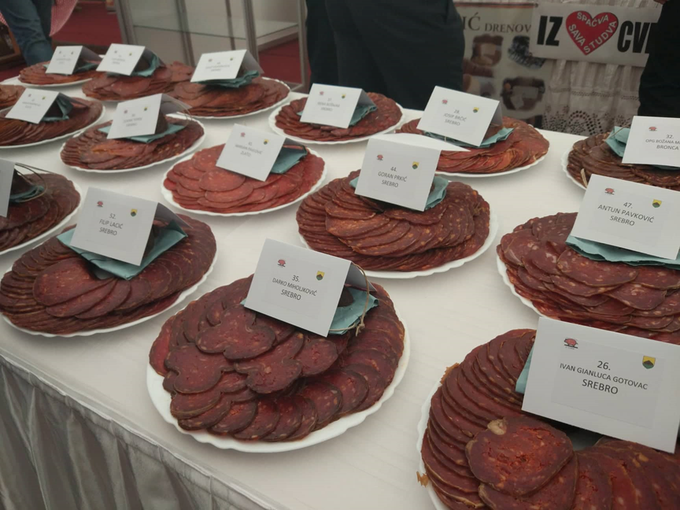

Autohtona jela možete kušati u:

Hotel „Villa Lenije“ Vinkovci
http://hotelvillalenije.com/novosti/wp-content/uploads/2015/05/Villa-Lenije_jelovnik.pdf
Hotel „Gem“ Vinkovci - http://hotel-gem.eu/
Hostel „Slavonija“ Vinkovci - http://hotel-slavonija.eu/
Hotel „Dunav“ Ilok - http://www.hoteldunavilok.com/
TN „Principovac“ Ilok - http://www.ilocki-podrumi.hr/?page_id=1103
Restoran „Stari podrum“ Ilok - http://www.ilocki-podrumi.hr/?page_id=1101
Acin salaš Tordinci - http://www.acinsalas.com/stranica/3
Restoran „Aquarius“ Bošnjaci - http://www.bp-aquarius.com/

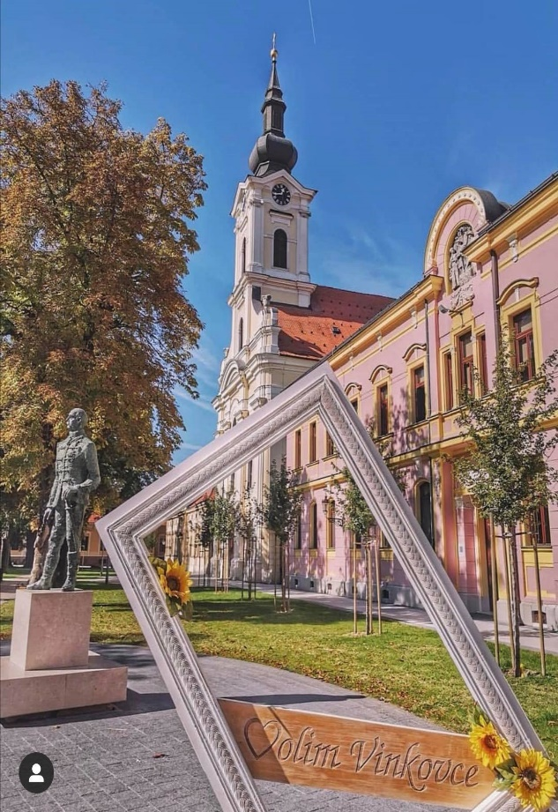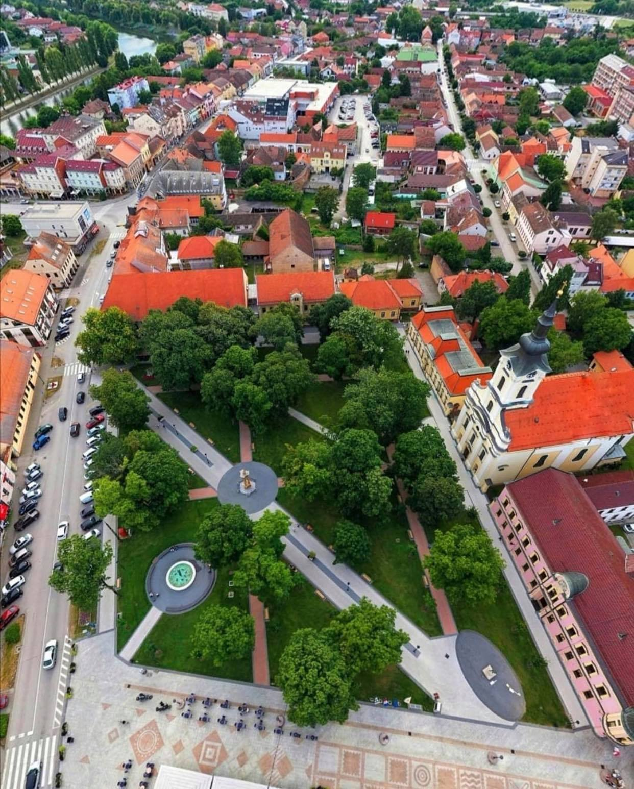
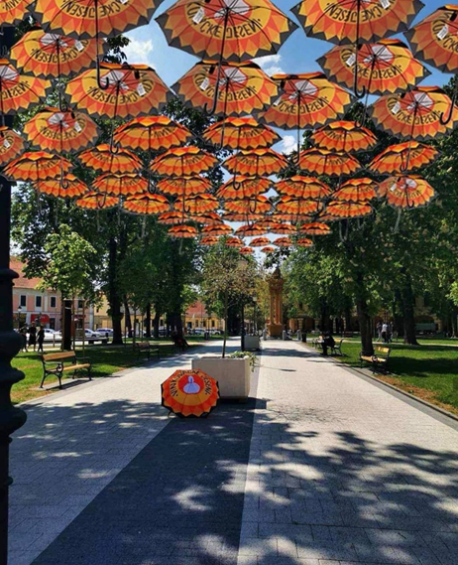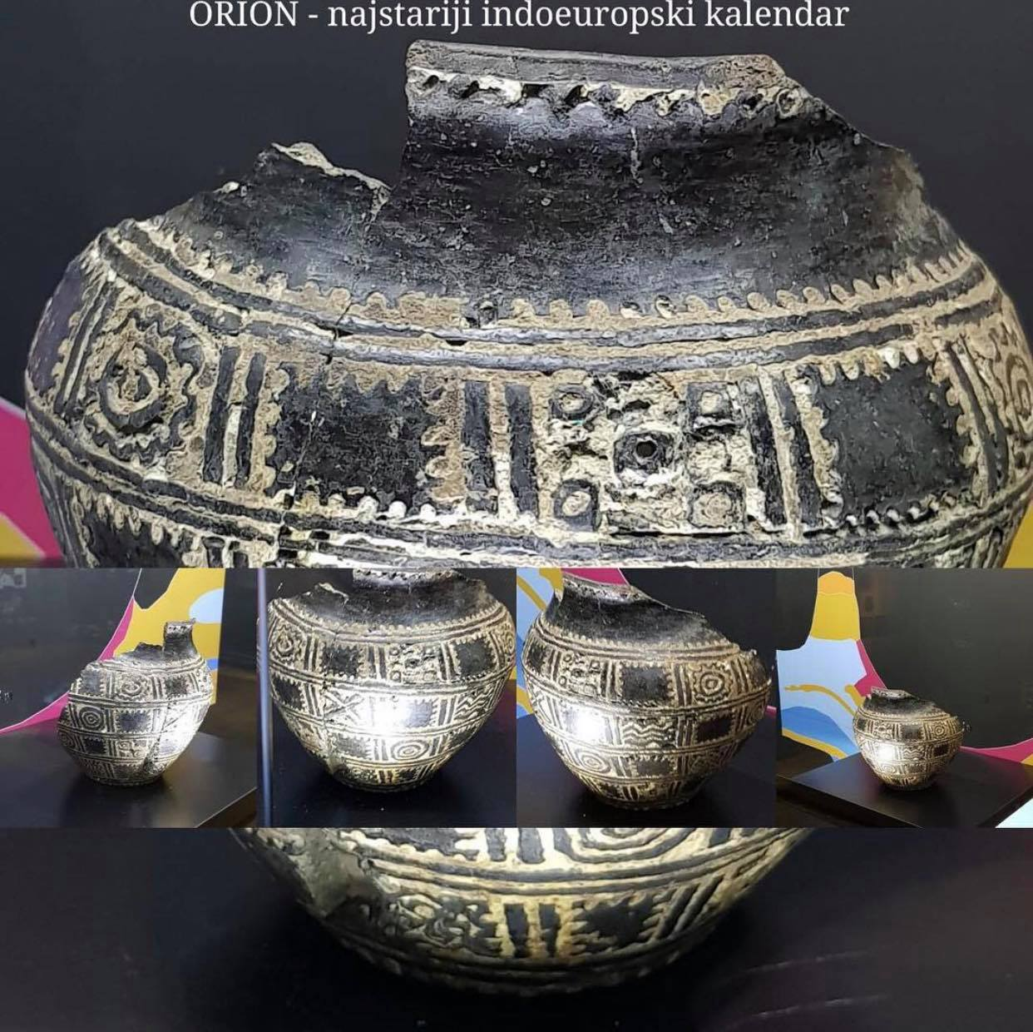
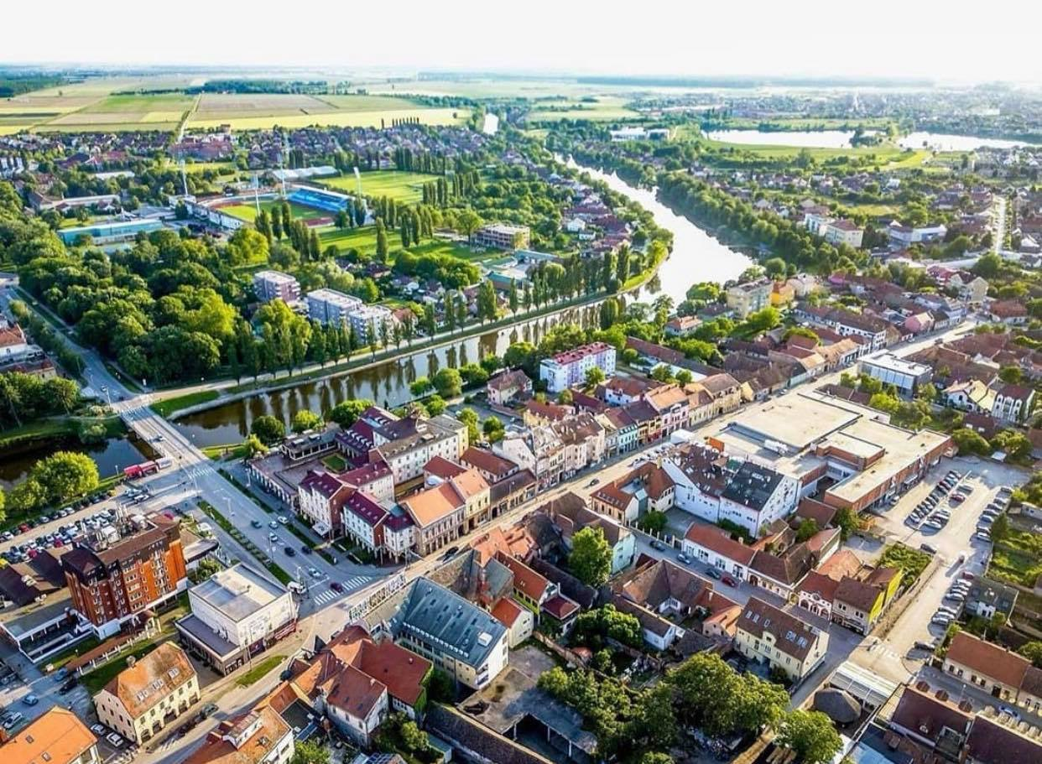

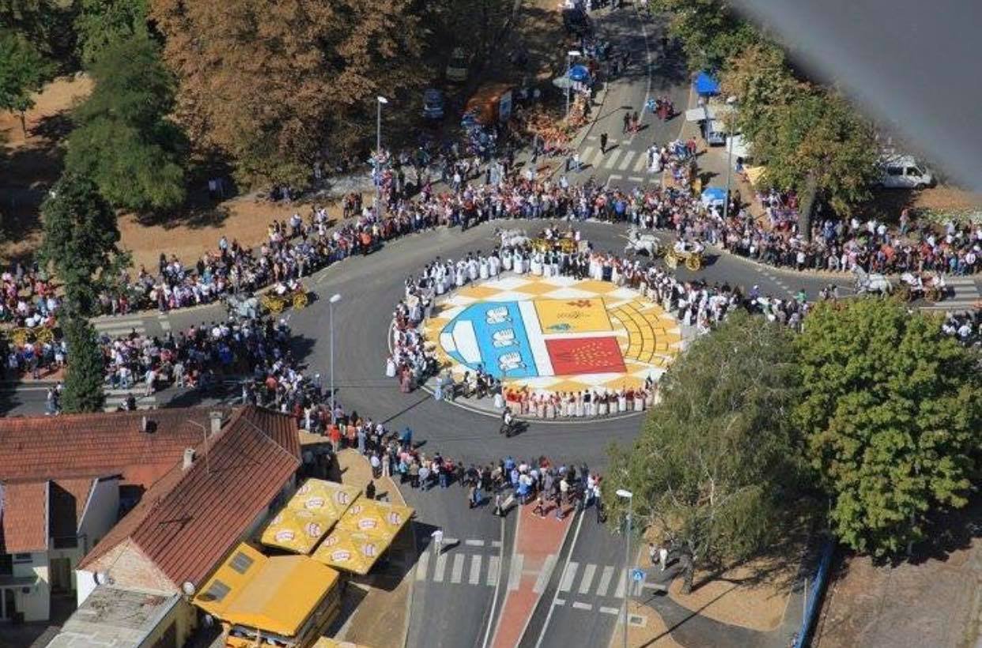

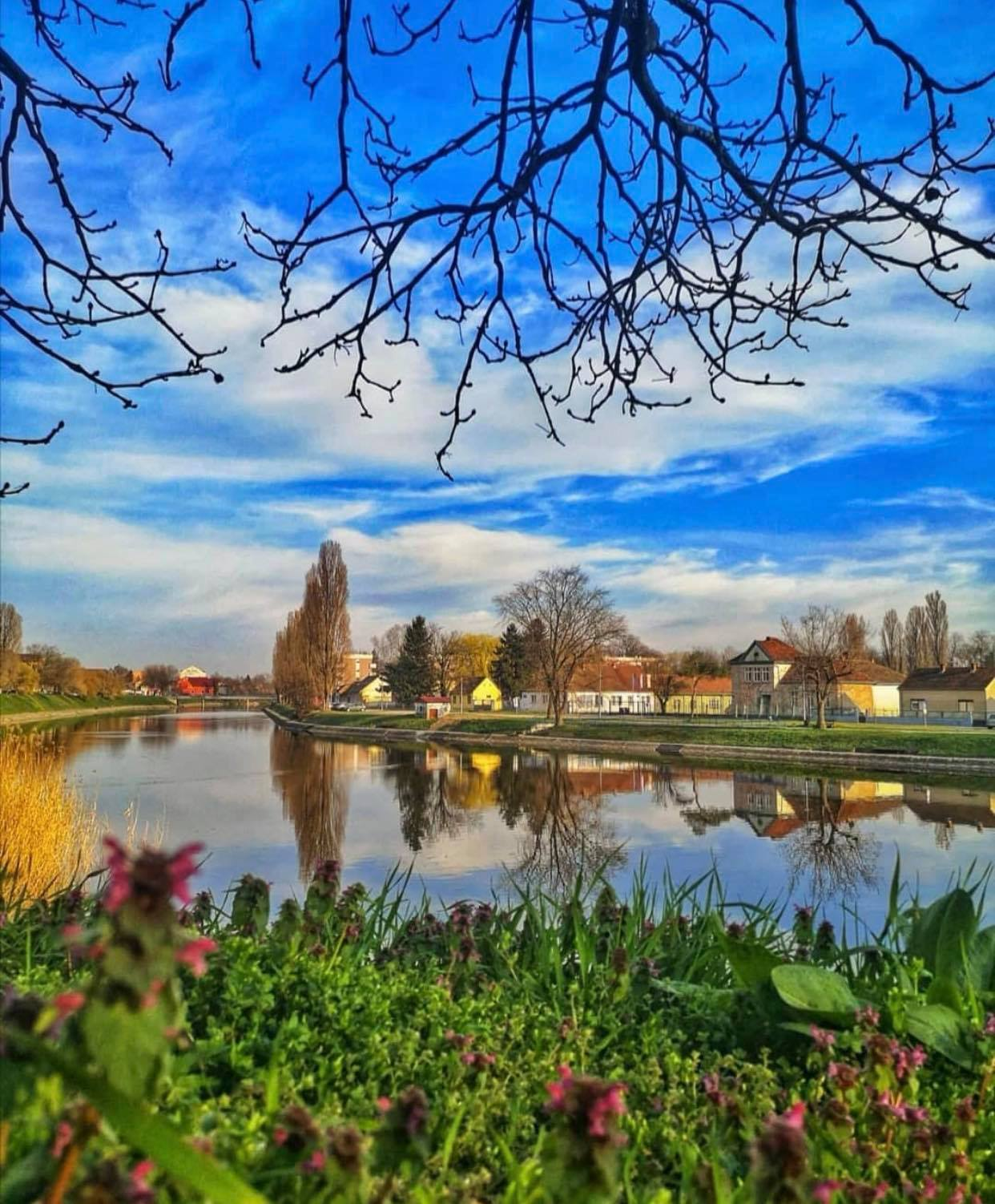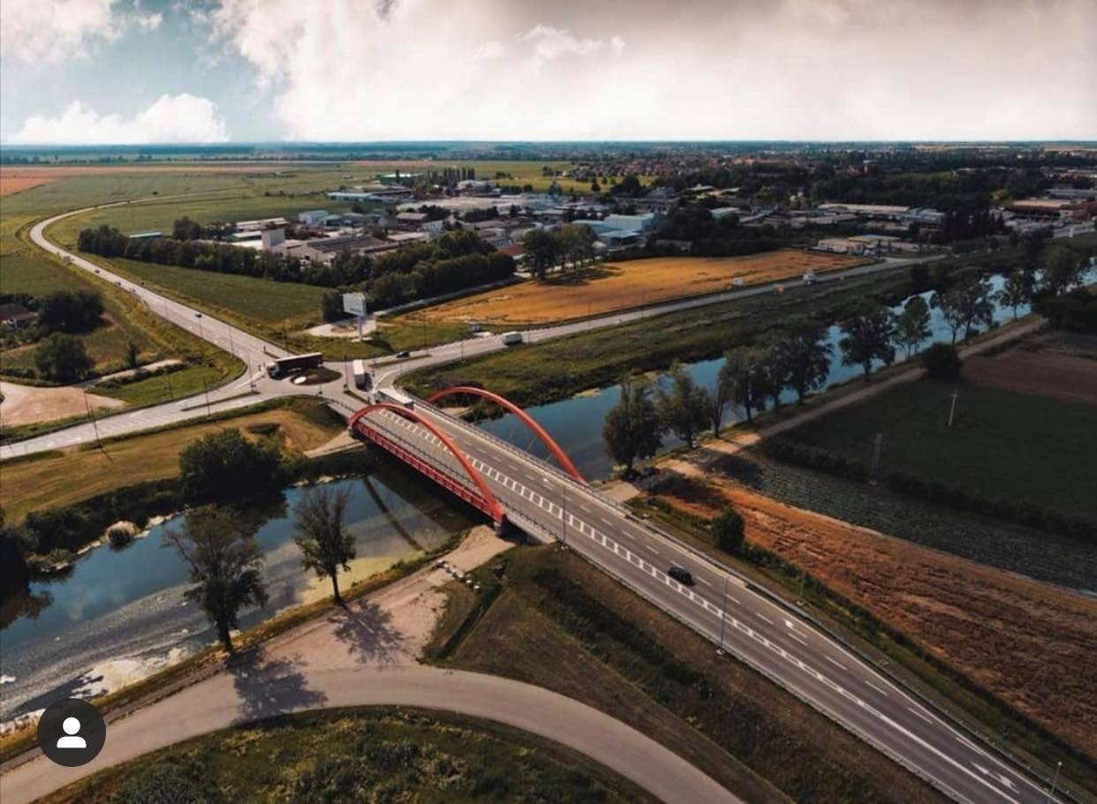

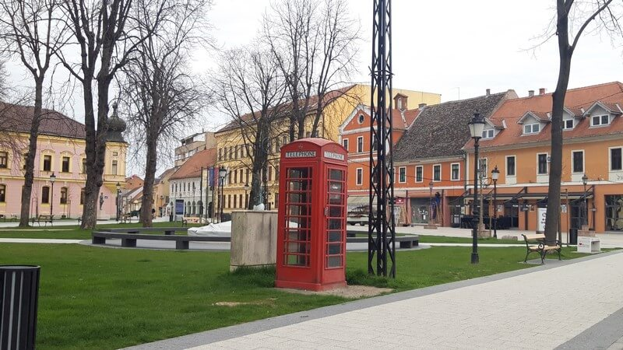

Kontakti:

Grad Vinkovci
Bana Jelačića 1, 32100 Vinkovci
Osoba za kontakt: Hrvoje Niče
+385 32 337 200
hrvoje.nice@vinkovci.hr
www.vinkovci.hr

AGENCIJA ZA RAZVOJ I INVESTICIJE
GRADA VINKOVACA – VIA d.o.o.
Glagoljaška 4, 32100 Vinkovci
Osoba za kontakt: Danijela Slipčević
+385 32 340 030
danijela.slipcevic@viavinkovci.hr
www.viavinkovci.hr

Informacije za ŠTAND:

Kontakt informacije:

Naziv lokalne zajednice: Grad Vinkovci
Ime i prezime osobe/osoba koja će se nalaziti na štandu (virtualnom) u toku sajma:
Hrvoje Niče
Kontakt e-mail: hrvoje.nice@vinkovci.hr
Kontakt Telefon: +385 (0)32 493308
Adresa, grad, država: Bana Jelačića 1, 32100 Vinkovci, RH
Link za zoom ili neki drugi komunikator preko kojeg želite održavati B2B sastanke:
Web adresa: www.grad-vinkovci.hr
Linkovi za društvene mreže:

O LOKALNOJ ZAJEDNICI:

Navedite sve informacije o Vašoj lokalnoj zajednici za koje smatrate da su bitne u predstavljanju (poželjno i na engleskom jeziku zbog ino-partnera), kako biste publici i investitorima približili vašu sredinu, sve ideje za buduće projekte i investicije, poslovne zone i dr. za privlačenje kapitala. Navedite i sve najbitnije kompanije iz Vaše sredine iz raznih djelatnosti kako bi mogli također komunicirati sa potencijalnim investitorima.
Dostavite i gotove PROJEKTE koje imate za ponuditi investitorima, kako bi ih mogli postaviti na platformu gdje će ih vidjeti investitori.

Pored ovih informacija u word-u odvojeno trebate dostaviti:

- Video promo o Vašoj lokalnoj zajednici ili link gdje je prikazan
https://youtu.be/uOCjtrZRa0o

- Brošure, slike, sve što smatrate da je zanimljivo iz Vaše lokalne zajednice koje će da stoje u rubrici O Lokalnoj zajednici.

- LOGO lokalne zajednice koji želite da se nalazi na štandu i logo kompanija iz Vaše sredine

Ovaj sajam će biti aktivan tokom cijele godine.

